IBM Endpoint Manager

Creation of Parameterized Fixlets

Document Version: 1.0

Document Revision Status: [Release]

Document Date: 17/02/2015

Document Control Information

Document Owner: James MacKenzie
Document Author: James MacKenzie / Kabir Ahmed

Summary of Changes:

Version | Date | Short Description
0.82 | 12/08/14 | Initial Version
0.83 | 12/08/14 | Added parameter sections
0.84 | 12/08/14 | Added more information and examples on linked lists
0.85 | 05/12/14 | Reviewed for release
0.9 | 05/02/15 | Updated release candidate
0.91 | 16/02/15 | Dara Murphy – Minor changes for release
0.92 | 16/02/15 | Minor updates for index
1.0 | 17/02/15 | Release version

Table of Contents
Introduction to Parameterization in IEM 4
What is a parameterized Fixlet 4
Why do we require parameterized Fixlets 4
Creating a simple Parameterized Fixlet 5
Step 1 – Obtain a current BES file template 5
Step 2 – Add the bootstrap section to the Fixlet 8
Step 3 – Configure the parameters required for the Fixlet to work 9
Step 4 – Use the parameters in the action section 10
Adding Parameter Validation or Customization to our Fixlet 12
Validation of parameter entries 12
Modification of parameter entries 14
Secure Parameters 16
Adding Other Input field Types 17
Adding a Select type input 17
Adding a large text area input field 18
Adding a Multi-select Input box 19
Linked Select Boxes 20
Country to City Example 20
Timezone example with custom modifications 22
Parameterized File Selection 24
Ability to disable/enable parameter validation 28
Sections of Parameters 30
Quick Reference Guide 33
ParameterMetadataTag 33
BES Fixlet Analysis MetaData 39
API Information 40

Introduction to Parameterization in IEM

What is a parameterized Fixlet

A parameterized Fixlet enables a user to satisfy variables before taking actions. These variables are defined through HTML inputs available in the Fixlet description.
Here is a very simple example.

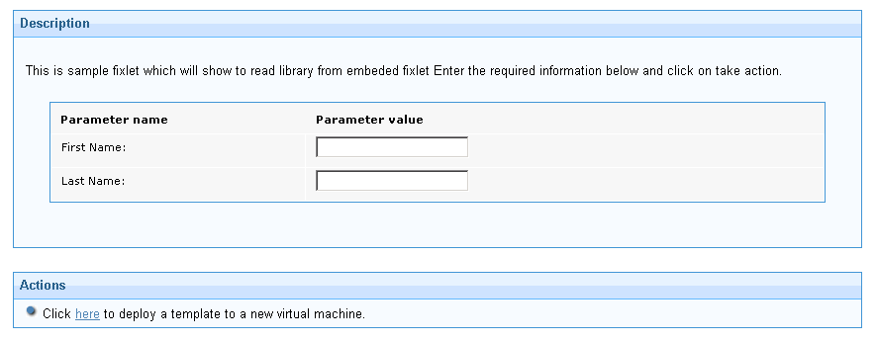
The toolset that is provided enables creation of simple Fixlets through to advanced parameterisation where values are input using different methods, retrieved from other sources, linked between parameters, secured to the endpoint and validated or manipulated prior to take action.

Why do we require parameterized Fixlets

Often when creating a Fixlet it is required to have options to control how that Fixlet operates in different environments. This is especially true when performing software installations through IEM. Generally these will be performed as unattended installations and therefore the questions that would normally be answered as a part of the install GUI need to be defined. It is possible to define all of these in the action script or using a MST file for an MSI install. This would require that more Fixlets exist for the same package install if different sets of install parameters are required. A simple example of a parameter would be to define the installation path for a package.

There are several solutions that have been used in IEM to solve this problem. What we are providing here is a centrally supported toolset to enable the simple creation and maintenance of parameterized Fixlets.

Creating a simple Parameterized Fixlet

Before we go any further we will create a simple parameterized Fixlet in IEM using two parameters for first name and last name. This will introduce the basics of the parameterized Fixlet. We will then build on this to introduce the more advanced capabilities.
We will build the Fixlet BES file outside of IEM then import the .bes file through the console.

Step 1 – Obtain a current BES file template
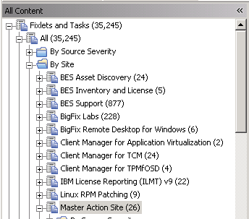

From the IEM select the All Content Domain then select 'Fixlets and Tasks' and then drill down to find the 'Master Action Site'. This is the default site for creating custom content but you can use any custom site if you wish.
In the list panel which is on the right hand top pane that displays the Fixlets, right click with the mouse and select 'Create New Fixlet'. Give it a name and press the OK button at the bottom to save and create the Fixlet.
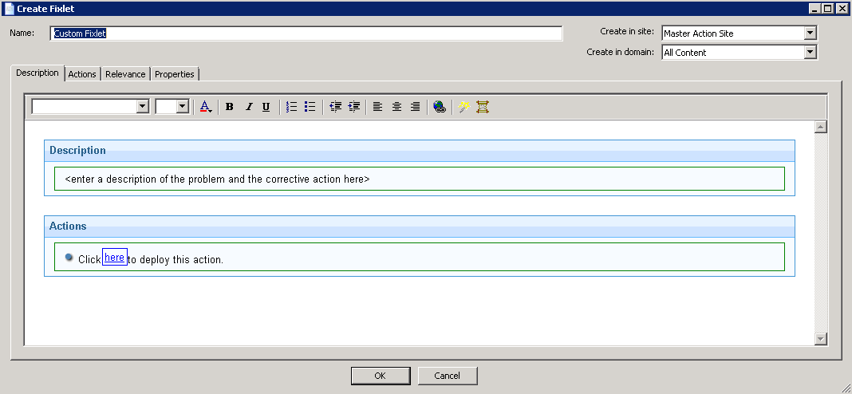
The Fixlet will now be displayed. Click the export button to export it as a BES file.
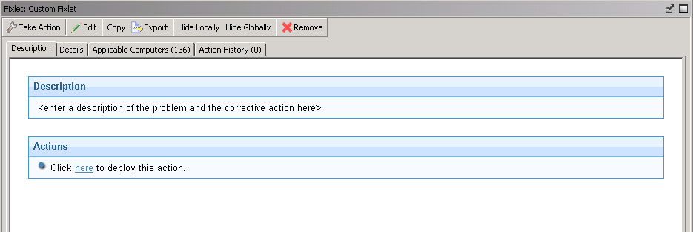
We will now have a file that looks something like this:

<?xml version="1.0" encoding="UTF-8"?>
<BES xmlns:xsi="http://www.w3.org/2001/XMLSchema-instance" xsi:noNamespaceSchemaLocation="BES.xsd">
<Fixlet>
<Title>Custom Fixlet</Title>
<Description><![CDATA[&lt;enter a description of the problem and the corrective action here&gt; ]]></Description>
<Relevance>true</Relevance>
<Category></Category>
<Source>Internal</Source>
<SourceID></SourceID>
<SourceReleaseDate>2014-07-22</SourceReleaseDate>
<SourceSeverity></SourceSeverity>
<CVENames></CVENames>
<SANSID></SANSID>
<MIMEField>
<Name>x-fixlet-modification-time</Name>
<Value>Tue, 22 Jul 2014 10:43:28 +0000</Value>
</MIMEField>
<Domain>BESC</Domain>
<DefaultAction ID="Action1">
<Description>
<PreLink>Click </PreLink>
<Link>here</Link>
<PostLink> to deploy this action.</PostLink>
</Description>
<ActionScript MIMEType="application/x-Fixlet-Windows-Shell">// Enter your action script here</ActionScript>
</DefaultAction>
</Fixlet>
</BES>

Step 2 – Add the bootstrap section to the Fixlet

For the simplest parameterized Fixlet we need to add three parts to this .bes file. For the first section we will call the bootstrap or boiler plate code as it loads the parameterization library. This goes into the description section of the Fixlet.
Here is what the section should look like, note the <Description><![CDATA[ and ]]></Description>; sections are existing.
<Description><![CDATA[
<DIV id=fixletMessage2 class=FixletMessage>
<DIV id = paramFixletDescription>
<P>
This is sample Fixlet which will show to read library from embeded Fixlet
Enter the required information below and click on take action.
</P>
</DIV>
<script>
loaded = false;
var CODE_SITE_NAME = 'BES Support' ;
function loadScript (siteName, callback) {
loaded = false;
var relevanceQuery ='( value of it) of (mime fields of (bes fixlets whose ( name of it = "Parameterized Fixlet Library" and name of site of it = \"' + siteName + '\" ))) whose (name of it = "vrt_utils.js")'
var code = EvaluateRelevance(relevanceQuery);
var head = document.getElementsByTagName("head")[0];
var script = document.createElement("script");
script.type = "text/javascript";
script.text = code;
head.appendChild(script);
callback();
}
function scriptLoaded(){
if (!loaded){
if ( typeof FixletUtils !== 'undefined') {
loaded = true;
/*
* Pleas Note: The following code will be moved to library with next publish of lib and user will have to only call method
*/
var relQuery = "(messages of it) of bes fixlets whose (name of it = \"Parameterized Fixlet Library\" and ((name of it ) of site of it = \"" + CODE_SITE_NAME +"\" ))";
var messages = EvaluateRelevance(relQuery);
var regex = /\s*<DIV id=globalizationMessageDiv style="display:none;">([\x00-\x7F]+)\s*<\/Div>/i;
var matches = regex.exec(messages);
matches[1]=matches[1].replace(/<br>/gi,"");
eval(matches[1]);
FixletUtils.initFixletRender();
} } }
loadScript(CODE_SITE_NAME, scriptLoaded);
</script>
<DIV class=FixletProperty></DIV></DIV>
]]></Description>
Be careful when copying and pasting this section to avoid distorting any of the sections that could cause the Fixlet to fail.
Now we have the code in place we can start using it.

Step 3 – Configure the parameters required for the Fixlet to work

This step is defining the parameters that we want to expose in the Description field. If we look at the original BES file template, we will see a section like the following:

<MIMEField>
<Name>x-fixlet-modification-time</Name>
<Value>Tue, 22 Jul 2014 10:43:28 +0000</Value>
</MIMEField>
We call these sections MIME Fields, There can be zero or more of them in a valid bes file. Each MIME field entry has a name and value section. The name must be unique.
We are going to create a new section called parametermetadatatag and use it to configure two text box entry fields for 'first name' and 'last name'.
Note: the Value field for our custom MIME field entries is always going to be some form of JSON data (JavaScript Notation):
<MIMEField>
<Name>parametermetadatatag</Name>
<Value><![CDATA[{
"fName": {
"Name": "firstName",
"Title": "First Name:",
"Description": "Enter the first name",
"UIType": "Textbox"
},
"lastName": {
"Name": "lastName",
"Title": "Last Name:",
"Description": "Enter last name:",
"UIType": "Textbox"
}
}]]></Value>
</MIMEField>

Basically, we have defined the bare minimum required entries to declare two text boxes with a name (for reference), a title (for display), a description (for hover over information) and a UIType to declare it a text box. We will deal with the full options available later.

Step 4 – Use the parameters in the action section

Now that we have declared the parameters that we want to collect for this Fixlet it is important that we understand how to use them.
In our example we have two attribute value pairs that can be used in the action. These are firstName and lastName. They are case sensitive.
The first thing to point out is that we can optionally expose the parameters as 'action parameter query'. If the value was not populated in the Description field the old popup and collect method will still work. If it is populated, then we will mask the old popup collection method. Interestingly if we have the action parameter query in the Fixlet with no matching MIME field pairing, the code will still expose the text entry field in the description.
We do not have to use or expose them in the action. That would be pointless in this example, but the Fixlet would still work.
To use the parameters regardless of how they are collected, they are referenced as
parameter { “paramName” } where paramName is the name of the parameter.
So in our example we can use them as follows:
Replace the existing text // Enter your action script here with this:
parameter "tempdir" = "{windows folder}\temp"
parameter "response_filepath" = "{parameter "tempdir"}\names.rsp"
createfile until __EOF__
//File with name details
FirstName={parameter "firstName"}
LastName={parameter "lastName"}
__EOF__
move __createfile "{parameter "response_filepath"}"

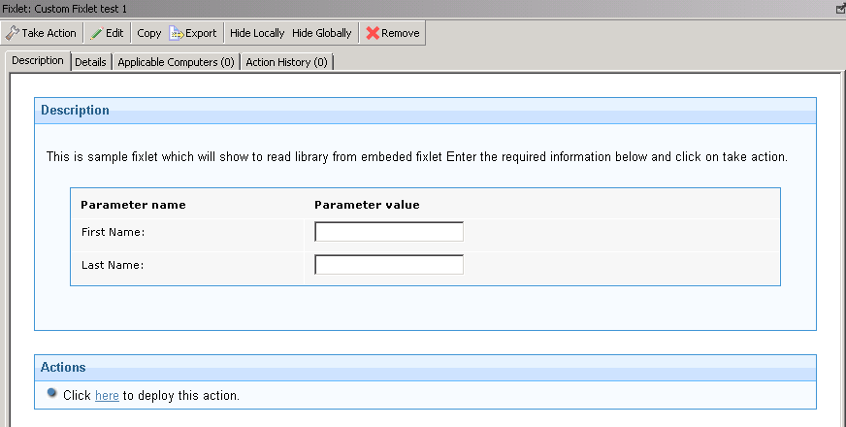
We now have a complete Fixlet that we can import and run.
Hopefully this works for you. This has proven that we can create a custom parameterized fixlet and if you run it it should create a names.rsp in the Windows temp directory containing the correct values.

Adding Parameter Validation or Customization to our Fixlet
Now that we have a working parameterized Fixlet, we might want to add validation to the entry. We might also want to modify the strings collected by changing them to upper or lower case. In this section we will explore how to do this.

Validation of parameter entries

There are some built-in validation methods that can be used. An example is the ability to add this to the input definition for a text box:
"DataType" : "Text"

This will check that we have text and not an integer.
If we add:
"Required":"1"

It means that we will not accept a blank value. This will also add an asterisk to the left side of the parameter name.
We can also choose to validate one or more of the parameters that we have created at 'Take Action' event time. This is done by adding custom validation javascript to a new MIME field section called ParameterValidatorTag.
We are going to create a new section called parametermetadatatag and use it to validate that the first name value we collected is not blank, contains only the chars a-z (case insensitive) and is 1 up to 30 chars long.

<MIMEField>
<Name>ParameterValidatorTag</Name>
<Value><![CDATA[{
validateUserName : function (validationObj ) {
var currentValue = validationObj["currentValue"];
if ( !currentValue.match(/^[a-z]{1,30}$/i))
return "The name format is not correct";
}
}]]></Value>
</MIMEField>
Now add the following customValidator link to both the firstName and lastName parameters. Do not put a comma on the end of the line above.

"CustomValidator" : "validateUserName"

So it will be something like this:

<Value><![CDATA[{
"fName": {
"Name": "firstName",
"Title": "First Name:",
"Description": "Enter the first name",
"UIType": "Textbox",
"CustomValidator" : "validateUserName"
},
"lastName": {
"Name": "lastName",
"Title": "Last Name:",
"Description": "Enter last name:",
"UIType": "Textbox",
"CustomValidator" : "validateUserName"
}
}]]></Value>

Save it as a different file to differentiate from the first one. If you load this to IEM, you can test that it fails when you enter the wrong value.

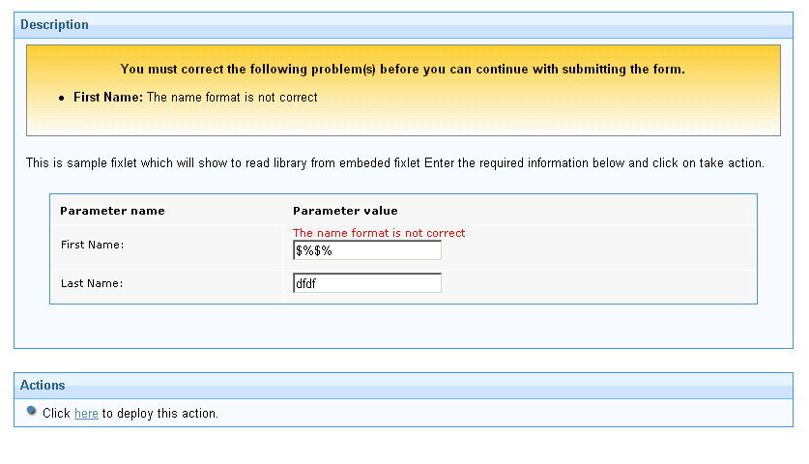
You can see the error that comes up when we try to 'Take Action'. This ensures that we do not take actions with invalid parameters.

Similar checks can be made on integer values. For example:

validatePort : function (validationObj ) {
var currentValue = validationObj["currentValue"];
if ( currentValue < 1024 || currentValue > 65535 ) {
return "Port specified [“+currentValue+”] is outside of valid range";
}
}

Modification of parameter entries

We might want to modify the inputted parameters for use in the action script. A good example might be to change the characters from lower to upper case or vice versa.
This example is to change the case for the firstName to all lower case.
This is again done through a new MIME field entry called ParameterCustomEventsTag
Copy and paste this into the BES file.

<MIMEField>
<Name>ParameterCustomEventsTag</Name>
<Value><![CDATA[{
makeUpperCaseName : function (validationObj , metaDataobjects ) {
return (validationObj.toUpperCase());
}
}]]></Value>
</MIMEField>

Now add the new line to the firstName set of attributes (do not forget the comma at end of the previous line):

"CustomEvents": [{"event":"onFormSubmit","action":"makeUpperCaseName"}]

You will see the changes made if you execute the Fixlet and look inside the created names.rsp file.
You can trigger the Custom events from any event you choose and could update the visible form data if required.
All the HTML Tags for a particular control are supported, other than that we have introduced three new events:

- onFormSubmit: This event is called when the 'take action' button is clicked. You can use this event for a particular control to modify its value, for example, making it upper case or to send 1 or 0 for what is displayed to user as true/false.
- OnRelevanceResult: This event will be called when a relevance query is executed and result is passed back to this event function. You can extract your result using following var yourResult = eventObject["relevanceResult"];
The return value for this event is an array of values to be populated. If the receiving control is a select list then all the data in array will be populated. If the control is a text box then the first value in the array will be displayed. The array can have two indices, the first index will be treated as the key and the second index is the value for the control.
- onFixletRender: This is a special event. It is defined in the same tag but not associated to any field. If defined it is always executed.

Secure Parameters
From IEM 9.0 we have an ability to pass secure parameters using the parameterization library. This is done by adding an additional attribute to the parameter metadata to indicate that the parameter is to be secured.
Note: Encypted parameters cannot specify Action Parameter Query entries in the action script. Doing so will trigger the action parameter query to popup when taking an action.
It is more expensive to make a parameter secure so you should only use this when required.
The Encrypt attribute will cause the value to be encrypted.
"Encrypt" : "true"

The subUIType as password will cause the value to be obscured when entered.
"SubUIType" : "Password",

To test this we should add two new fields to our Fixlet.
"UserName": {
"Name": "UserName",
"Title": "User Name:",
"Description": "Enter the user name that you want to use.",
"UIType": "Textbox",
"Required":"1",
"DataType" : "Text"
},
"Password": {
"Name": "Password",
"Title": "Password:",
"Description": "Enter password that corresponds with the user name.",
"UIType": "Textbox",
"Encrypt" : "true",
"SubUIType" : "Password",
"Required":"1",
"CustomEvents": [{"event":"onFormSubmit" , "action":"submitUserPassword"}]
}
If successful, you should see something like this:

Adding Other Input field Types
So far we have only used a simple text box type of input field to capture the forename and surname fields. Clearly there are requirements when we will wish to use other types of entry to ensure speed of use and accuracy. This section will cover examples of this.

Adding a Select type input
A simple selection box is very useful for parameterized Fixlets. In this example we will add an additional input field to capture the gender of the individual.
Here is the code that we need to add to the parametermetadatatag section. This is a JSON string so you need to add the comma beforehand:

"gender": {
"Name": "gender",
"Title": "Select your gender:",
"Description": "Select the gender of the individual.",
"UIType": "Select",
"ValueType": "specified",
"Values": ["Male","Female"]
}
Load this and you should see the new input field as such:
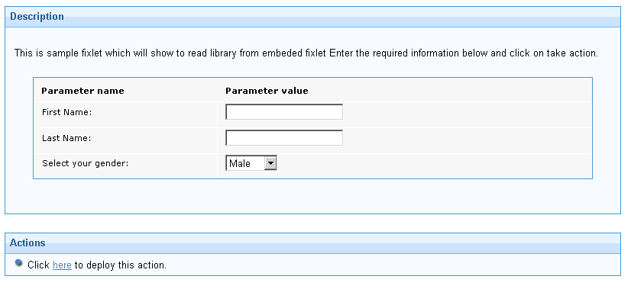
Now if we wished to default this value to Female then we would specify the additional line as follows:

"gender": {
"Name": "gender",
"Title": "Select your gender:",
"Description": "Select the gender of the individual.",
"UIType": "Select",
"ValueType": "specified",
"Default": "Female",
"Values": ["Male","Female"]
}

As you can see in this previous example, the key/value pair for each select entry are the same, male or female. This can be changed so we can pass a different value to the selection key. In this example we will pass the value 1 for Male and 0 for female.
"gender": {
"Name": "gender",
"Title": "Select your gender:",
"Description": "Select the gender of the individual.",
"UIType": "Select",
"ValueType": "specified",
"Default": "0",
“Values” : [{"key":"Male" , "value":"1"}, {"key":"Female","value":"0"}]
}

The UI will not be altered but the values passed to the action script and to the user.rsp file will be different.

Adding a large text area input field

A textArea input field type is essentially the same as a textBox but has 5 visible lines and 30 scrollable lines. In this example we will add a comments box for the form.

"comments": {
"Name": "comments",
"Title": "Enter comments:",
"Description": "Enter any additional comments",
"UIType": "textArea",
"Default": "No comment"
}

Adding a Multi-select Input box

Often it is desirable to have a single input where the user can select zero or more entries for use in the action script.
This is performed by using an input called multilinetext which works exactly the same as standard text box but will allow multiple selections.
In this example we will create a multilinetext input for selecting fruits that a person likes to eat:

"fruits": {
"Name": "fruits",
"Title": "Select fruits that you enjoy eating:",
"Description": "Select fruits that you enjoy eating",
"UIType": "multilinetext",
"ValueType": "specified",
"Values": ["Banana","Orange","Pineapple","Apple","Grapes","Peach","Pear","Lime","Avocado","Strawberry","Raspberry"]
}

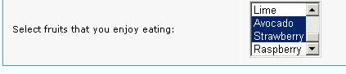

It is possible to get data from relevance or both (hybrid) as well.
This example will retrieve all the names of the computers registered in IEM and present them in a select list. Using the Ctrl key, the user can select multiple values.

"Computers": {
"Name": "Computers",
"Title": "Computers Owned:",
"Description": "Select all the computers you own from the list.",
"UIType": "multilinetext",
"FormOnly" : "true",
"ValueType": "relevance",
"Values": "(name of it) of bes computers"
},

Linked Select Boxes
A special supported use case is to have linked select boxes. For this we specify a parent/child relationship. When the parent value is changed, the options that are available for the child selection are dynamically changed. This can be cascaded to as many levels as you want. The linkage can be done either while executing dynamic values (relevance query) or if you have static data to populate.
As always, the best (and easiest) way to explain this is through examples.

Country to City Example
The first example is a simple Country / City linkage. The cities will display for the chosen country. Here is the code showing static linkage to try.
"country": {
"Name": "country",
"Title": "Select country:",
"Description": "Select country",
"UIType": "select",
"ValueType": "specified",
"Values": ["Scotland","England","Ireland","Wales"]
},
"city": {
"Name": "city ",
"Title": "Select city:",
"Description": "Select city",
"UIType": "select",
"ValueType": "specified",
"Parent": "country",
"Values" : [
{"key":"Edinburgh", "value": "Edinburgh" , "parentValue":"Scotland"},
{"key":"Glasgow", "value": "Glasgow" , "parentValue":"Scotland"},
{"key":"Dublin", "value": "Dublin" , "parentValue":"Ireland"},
{"key":"Galway", "value": "Galway" , "parentValue":"Ireland"},
{"key":"Cork", "value": "Cork" , "parentValue":"Ireland"},
{"key":"London", "value": "London" , "parentValue":"England"},
{"key":"Manchester","value": "Manchester" , "parentValue":"England"},
{"key":"Cardiff", "value": "Cardiff" , "parentValue":"Wales"}
]
}
This should display like the following screenshot. Changing the Country will change the values offered from the City selections.
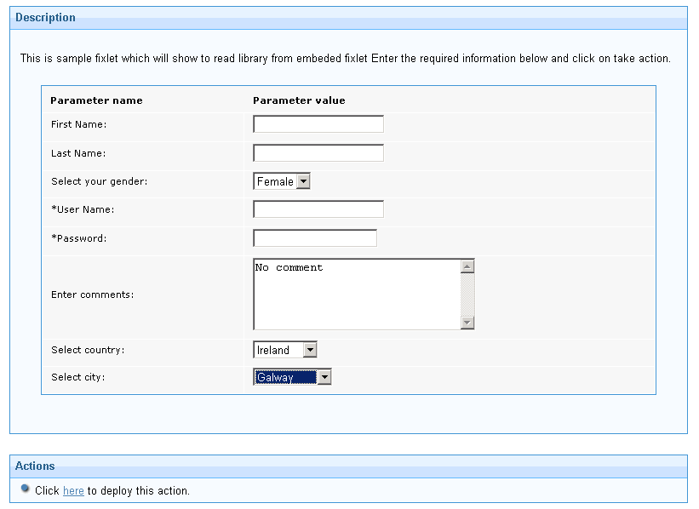
In this example the values from the city and the country are submitted as individual values into the action script.

Timezone example with custom modifications

It may be required to perform some manipulation on the data to submit a modified value in certain circumstances. Here are some examples:
Add this into the parametercustomeventstag MIME Field
submitTimezone : function (elemValue, metaDataobjects ) {
var timezoneArea = FixletUtils.getElementValue("Area" , metaDataobjects);
var timezoneLocation = FixletUtils.getElementValue("TimeZone" , metaDataobjects);
var timeZone = timezoneArea + "/" + timezoneLocation;
return timeZone;
}

Now add these input options:
"Area": {
"Name": "Area",
"Title": "Timezone Area:",
"Description": "Select a timezone area for the virtual machine.",
"FormOnly" : "true",
"Required":"1",
"UIType": "Select",
"ValueType": "specified",
"Values" : [{"key":"Africa", "value": "Africa"} ,
{"key":"America", "value": "America"} ,
{"key":"Antartic", "value": "Antartic"}
]
},
"TimeZone": {
"Name": "TimeZone",
"Title": "Timezone Location: ",
"Description": "Select a timezone area for the virtual machine.",
"UIType": "Select",
"Required":"1",
"Parent" : "Area",
"ValueType": "specified",
"Values" : [
{"key":"Abidjan", "value": "Abidjan" , "parentValue":"Africa"},
{"key":"Accra", "value": "Accra" , "parentValue":"Africa"},
{"key":"Adak", "value": "Adak" , "parentValue":"America"},
{"key":"Anchorage", "value": "Anchorage" , "parentValue":"America"},
{"key":"Argentina/Catamarca", "value": "Argentina/Catamarca" , "parentValue":"America"},
{"key":"Argentina/ComodRivadavia", "value": "Argentina/ComodRivadavia" , "parentValue":"America"},
{"key":"Argentina/Cordoba", "value": "Argentina/Cordoba" , "parentValue":"America"},
{"key":"Argentina/Jujuy", "value": "Argentina/Jujuy" , "parentValue":"America"},
{"key":"Casey", "value": "Casey" , "parentValue":"Antartic"},
{"key":"Davis", "value": "Davis" , "parentValue":"Antartic"},
{"key":"DumontDUrville", "value": "DumontDUrville" , "parentValue":"Antartic"},
{"key":"Mawson", "value": "Mawson" , "parentValue":"Antartic"},
{"key":"McMurdo", "value": "McMurdo" , "parentValue":"Antartic"},
{"key":"Palmer", "value": "Palmer" , "parentValue":"Antartic"},
{"key":"Rothera", "value": "Rothera" , "parentValue":"Antartic"}
] ],
"CustomEvents": [{"event":"onFormSubmit","action":"submitTimezone"}]
}

When the timeZone is submitted, it will contain the area/Country rather than just the country.
This parent/child linkage can also be used with relevance statements (Dynamic linkage). In this case, the <Parent> tag in the relevance is changed to the value that is selected from the parent options. On changes, the relevance statement is re-evaluated and the child options are updated. The below code will automatically fetch computer Id based on the name selected in parent.
{
"Name": "computerName",
"Title": "Select Computer name",
"Description": "computers in Bes Server",
"UIType": "Select",
"ValueType": "relevance",
"Values": "(name of it) of bes computers",
"Required":"1"
},
{
"Name": "computer Id",
"Title": "Computer Id",
"Description": "Computer id",
"Parent" : "computerName",
"ValueType": "relevance",
"Values": "(id of it) of bes computers whose (name of it = \"<PARENT>\")",
"UIType": "Textbox",
"Required":"1"
},

There are cases in relevance query where you will have more than one dynamic value coming from different fields on the form. The rule here is there only can be one Parent, however, you can use $FieldName to get the other values.

Parameterized File Selection

Some Fixlets will require input files that are uploaded into IEM through the Software Distribution dashboard. When Fixlets use these files the prefetch block to download them requires the URL, SHA-1 (or SHA-2) and the file size. Obviously manually inputting these is troublesome so we can get these automatically and allow the user to select them.
In this example, we are selecting a file that is of a particular format (DB2 script file) and we have included validation tests on each field to check if they are OK. There are also complexities required to find out if a sha-1 or sha-2 is required for download and these are included in this example in the validateSHA1 and validateSHA2 functions.

<MIMEField>
<Name>parametervalidatortag</Name>
<Value><![CDATA[{
validateSize : function (validationObj ) {
var currentValue = validationObj["currentValue"];
if ( currentValue == 0 ) {
return "Cannot be zero";
}
},
validateSHA2 : function (validationObj, metadataObj){
var sha2Visible = FixletUtils.isVisible('db2_script_9_instsha2', metadataObj);
if (!sha2Visible) { return; }
var sha1Value = FixletUtils.getElementText('db2_script_9_instsha1', metadataObj);
var sha2Value = FixletUtils.getElementText('db2_script_9_instsha2', metadataObj);
var error ;
if (!sha1Value && !sha2Value){ error = "You must enter either SHA1 or SHA2 value" }
if (sha2Value && !error) {
var currentValue = validationObj["currentValue"];
if ( !currentValue.match(/^[0-9a-f]{64}$/i) ) {
error = "Can contain only hex characters and is of exactly 64 characters";
}
}
if (error ) { return error; }
},
validateSHA1 : function (validationObj, metadataObj ) {
/** Declare helper function to save code duplication */
(function () { validateSha1Only = function (){
var currentValue = validationObj["currentValue"];
if ( !currentValue.match(/^[0-9a-f]{40}$/i) ) {
return "Can contain only hex characters and is of exactly 160 bits"; }
} ;
})();
var error ;
var eVisible = FixletUtils.isVisible('db2_script_9_instsha1', metadataObj);
if ( !eVisible ) {
return;
} else {
var sha1Value = FixletUtils.getElementText('db2_script_9_instsha1', metadataObj);
var sha2Value = FixletUtils.getElementText('db2_script_9_instsha2', metadataObj);
if (!sha1Value && !sha2Value){ error = "You must enter either SHA1 or SHA2 value" }
if (sha1Value && !error) { error = validateSha1Only() ; }
}
if (error) { return error; }
},
validateScriptName : function (validationObj ) {
var currentVal = validationObj["currentValue"];
var len1=currentVal.length;
var n3=currentVal.indexOf(".sql");
var n4=currentVal.indexOf(".ddl");
var n=currentVal.search("http://");
var n1=currentVal.search("ftp://");
var n5=currentVal.indexOf(".sql.bfswd");
var n6=currentVal.indexOf(".ddl.bfswd");
if (n!=0 && n1!=0) {
return "Must begin with http:// or ftp://.";
}
if(n4!= len1-4 && n3!= len1-4 && n5!=len1-10 && n6!=len1-10) { return "Must end with .sql,.ddl or .bfswd.";
}
}
}]]></Value>
</MIMEField>
<MIMEField>
<Name>parametermetadatatag</Name>
<Value>{
"db2_script_9_insturl": {
"Name": "db2_script_9_insturl",
"Title": "URL of the DB2 script file:",
"Description": "Specify the URL of the script file.The http or ftp URL of the installation file with .sql or .ddl extension supported. For example,http://hostname:port/installer_path/script_name.sql.(The default port is 52311 for Bigfix HTTP server-Uploads directory).",
"UIType": "Textbox",
"Default": "http://",
"Required" : "1",
"BinaryHelper" : "URL-1",
"CustomValidator" : "validateScriptName"
},
"db2_script_9_instsha1": {
"Name": "db2_script_9_instsha1",
"Title": "SHA1 of the DB2 script file:",
"Description": "Specify the SHA1 of the DB2 script file.",
"UIType": "Textbox",
"DataType" : "Text",
"BinaryHelper" : "SHA1-1",
"CustomValidator" : "validateSHA1"
},
"db2_script_9_instsha2": {
"Name": "db2_script_9_instsha2",
"Title": "SHA2 of the Installation file:",
"Description": "Enter the SHA-2 of the DB2 script file.",
"UIType": "Textbox",
"DataType" : "Text",
"BinaryHelper" : "SHA2-1",
"CustomValidator" : "validateSHA2"
},
"db2_script_9_instsize": {
"Name": "db2_script_9_instsize",
"Title": "Size of the DB2 script file:",
"Description": "Specify the size of the DB2 script file in bytes.",
"UIType": "Textbox",
"DataType" : "Number",
"Required" : "1",
"BinaryHelper" : "Size-1",
"CustomValidator" : "validateSize"
}
}</Value>
</MIMEField>

When you add this successfully you will see something like this:

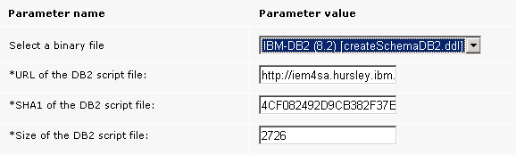
In the screenshot only the SHA1 value is displayed, and not the SHA2. This is because the IEM instance is set up to not require the SHA2 value when downloading files.

Selection of the various binary files will update the values of the URL, SHA and size fields. When you use these parameters you will require a prefetch section similar to the following example.

begin prefetch block
action parameter query "aix_db2_client_9_instsha1" with description "Enter the sha1 of the installation file" with default ""
action parameter query "aix_db2_client_9_instsha2" with description "Enter the sha2 of the installation file" with default ""
action parameter query "aix_db2_client_9_instsize" with description "Enter the size of the installation file" with default ""
action parameter query "aix_db2_client_9_insturl" with description "Enter the url of the installation file" with default ""
if {parameter "aix_db2_client_9_instsha1" is not equal to ""}
parameter "sha1_str" = "sha1={parameter "aix_db2_client_9_instsha1"}"
else
parameter "sha1_str"=""
endif
if {parameter "aix_db2_client_9_instsha2" is not equal to ""}
parameter "sha2_str" = "sha256={parameter "aix_db2_client_9_instsha2"}"
else
parameter "sha2_str" = ""
endif
parameter "item1" = "name={following texts of lasts "/" of parameter "aix_db2_client_9_insturl"} {parameter "sha1_str"} size={parameter "aix_db2_client_9_instsize"} url={parameter "aix_db2_client_9_insturl"} {parameter "sha2_str"}"
add prefetch item {parameter "item1"}
collect prefetch items
end prefetch block

Ability to disable/enable parameter validation
Sometimes you may want a user to select from a list, but you may also wish to allow them to input their own values if it is not in the list. This is where Override comes in handy.

"mainComputer": {
"Name": "Main Computer",
"Title": "Main Computer:",
"Description": "Select the main computer that you use. If not in the list, override and enter manually",
"UIType": "select",
"Override": "true",
"ValueType": "relevance",
"Values": "(name of it) of bes computers"
}

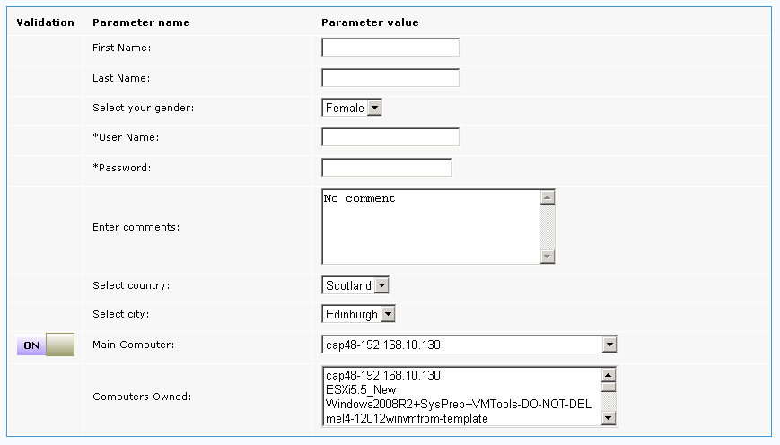
Sliding to Override does the following:
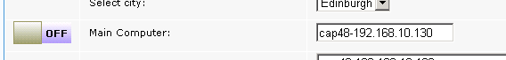

It leaves the current value in place and changes it to a free form text box. Note that any custom validation is now disabled.
If we also consider the linked list example, it is possible to allow the users to enter their own city (and country if required) by using the override option.

"country": {
"Name": "country",
"Title": "Select country:",
"Description": "Select country",
"UIType": "select",
"ValueType": "specified",
"Values": ["Scotland","England","Ireland","Wales"]
},
"city": {
"Name": "city ",
"Title": "Select city:",
"Description": "Select city",
"UIType": "select",
"ValueType": "specified",
"Override": "true",
"Parent": "country",
"Values" : [
{"key":"Edinburgh", "value": "Edinburgh" , "parentValue":"Scotland"},
{"key":"Glasgow", "value": "Glasgow" , "parentValue":"Scotland"},
{"key":"Dublin", "value": "Dublin" , "parentValue":"Ireland"},
{"key":"Galway", "value": "Galway" , "parentValue":"Ireland"},
{"key":"Cork", "value": "Cork" , "parentValue":"Ireland"},
{"key":"London", "value": "London" , "parentValue":"England"},
{"key":"Manchester","value": "Manchester" , "parentValue":"England"},
{"key":"Cardiff", "value": "Cardiff" , "parentValue":"Wales"}
]
},
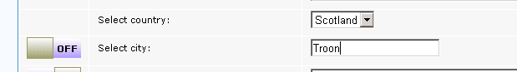

As you can see I can now enter in my own city of choice.

Override also has the effect of disabling any custom validation associated with the input field.

Sections of Parameters
We may be collecting parameters that pertain to different objects and this can prove confusing when presented in a large list. To resolve this issue we have the ability to break down the parameters into sections. This is configured in the parametermetadatatag section by adding the sections with the UIType “accordion”.
The following example builds on previous examples so it will require the custom validators to be defined. Note that the JSON structure is slightly different from the previous examples as each parameter is now a section value.
<MIMEField>
<Name>parametermetadatatag</Name>
<Value><![CDATA[{
"Section1" :{
"Name": "Section1",
"Title": "Personal Information",
"UIType": "accordion",
"Values": [
{
"Name": "firstName",
"Title": "First Name:",
"Description": "Enter the first name",
"UIType": "Textbox",
"CustomValidator" : "validateUserName",
"CustomEvents": [{"event":"onKeyDown","action":"makeUpperCaseName"}]
},
{
"Name": "lastName",
"Title": "Last Name:",
"Description": "Enter last name:",
"UIType": "Textbox",
"override": "true",
"CustomValidator" : "validateUserName"
},
{
"Name": "gender",
"Title": "Select your gender:",
"Description": "Select the gender of the individual.",
"UIType": "Select",
"ValueType": "specified",
"Default": "Female",
"Values": ["Male","Female"]
},
{
"Name": "UserName",
"Title": "User Name:",
"Description": "Enter the user name that you want to use.",
"UIType": "Textbox",
"Required":"1",
"DataType" : "Text"
},
{
"Name": "Password",
"Title": "Password:",
"Description": "Enter password that corresponds with the user name.",
"UIType": "Textbox",
"Encrypt" : "true",
"SubUIType" : "Password",
"Required":"1",
"CustomEvents": [{"event":"onFormSubmit" , "action":"submitUserPassword"}]
},
{
"Name": "comments",
"Title": "Enter comments:",
"Description": "Enter any additional comments",
"UIType": "textArea",
"Default": "No comment"
},
{
"Name": "country",
"Title": "Select country:",
"Description": "Select country",
"UIType": "select",
"ValueType": "specified",
"Values": ["Scotland","England","Ireland","Wales"]
},
{
"Name": "city ",
"Title": "Select city:",
"Description": "Select city",
"UIType": "select",
"ValueType": "specified",
"Override": "true",
"Parent": "country",
"Values" : [
{"key":"Edinburgh", "value": "Edinburgh" , "parentValue":"Scotland"},
{"key":"Glasgow", "value": "Glasgow" , "parentValue":"Scotland"},
{"key":"Dublin", "value": "Dublin" , "parentValue":"Ireland"},
{"key":"Galway", "value": "Galway" , "parentValue":"Ireland"},
{"key":"Cork", "value": "Cork" , "parentValue":"Ireland"},
{"key":"London", "value": "London" , "parentValue":"England"},
{"key":"Manchester","value": "Manchester" , "parentValue":"England"},
{"key":"Cardiff", "value": "Cardiff" , "parentValue":"Wales"}
]
}
]
},
"Section2" : {
"Name": "RegistrationInformation",
"Title": "Registration Information",
"UIType": "accordion",
"Values": [
{
"Name": "OwnerName",
"Title": "Owner Name:",
"Description": "Enter the name of the owner of the new virtual machine.",
"UIType": "Textbox",
"Required":"1",
"DataType" : "Text"
},
{
"Name": "OrganizationName",
"Title": "Organization Name:",
"Required":"1",
"Description": "Enter the organization name of the new virtual machine.",
"UIType": "Textbox",
"DataType" : "Text"
}
]
}
}]]></Value>
</MIMEField>

When successfully loaded you should see the following.
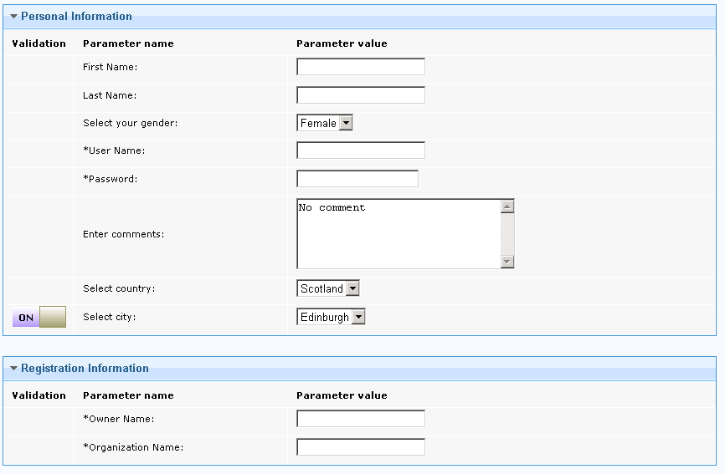
The twistys allow sections to be collapsed as required. Sections have no effect on how the parameters are passed into the action script.

Quick Reference Guide
This section is intended to be used to provide all the available parameters and some basic examples to help you construct advanced parameterized Fixlets easily.

ParameterMetadataTag

ParameterMetadataTag is the base of Fixlet parameters and is a required tag for Parameterized Fixlets - It is defined inside s Fixlet using the JSON string anywhere after the <description> tag and before the <DefaultAction> tags

The JSON String is constructed inside <MIMEField> tag:

Tag Name | Tag Value
Name | Parametermetadatatag | The Name of the tag describing metadata for form
Value | <![CDATA[{}]]> | The following will come inside CDATA section. The format of data is “JSON_KEY”: {JSON Value} – The JSON Value is again a key value pair and explained below.

Example:

<MIMEField>
<Name>parametermetadatatag</Name>
<Value><![CDATA[{

}]]>
</Value>
</MIMEField>

In the above table the tag name “value” , has CDATA section. The following JSON is defined under this CDATA section:

Name | Required | Description
Name | Yes | Name of the Html control. The Name must not have spaces or special characters like [{(.&%^*”'`¬|)}] - The name can contain alpha numeric and _
Title | Yes | Title of Html control
Description | Yes | Description associated with the control. This will be used to explain what this field is used for. The description is shown as tool tip
UIType | Yes | Type of control to be rendered. The following control are supported so far  Select : The select List which allows a single selection from the provided values  multilinetext : Works the same as a select list but allows multiple selections  Textbox : The text box with a default size of 30 chars displayed.  TextArea : Same as text box but has 30 lines of text available with 5 visible lines and a scroll control. Max chars are 5000.  accordion : Creates a section of parameters where the defined values are the parameters.
SubUIType | No | The SubUIType is sub type of a control e.g. Textbox can have user input in plain characters or masked characters e.g. password. SubUITypes currently supported are  password :  This is supported only for Text box.
Encrypt | No | This is required for secure parameters and can only be used from IEM 9.0 onwards. It uses IEM's mailboxing feature to securely deliver the parameters value to the endpoint  The value must be "true"
ValueType | Yes | ValueType defines what type of value will be used.  The options of ValueType are:  "specified" : The list will be populated with the values specified.  "relevance" : The list will be populated with the relevance query result. For select list the whole relevance result will be populated However in the case of Textbox if a relevance query returns more than one result only the first one will be displayed. The relevance query is specified under the key name values.  “Hybrid”: This type is combination of relevance and specified values. Example of this type is given under Values
Values | Yes | This will provide the values to the control and the nature of it dependes upon ValueType.  There are three types of ValueType supported;  - specified  - relevance  - hybrid .  See the example of each of the three  Specified.  Mention a simple Array:  “Values” : {["1", "2"]}  Or a Key Value Pair Array:  “Values” : [{"key":"1" , "value":"On"}, {"key":"0","value":"Off"}] –  The value specified is the display value presented to the user and the key is sent to the back end. This enhances the usability.  Relevance  Mention a relevance query to get the values.  "Values": "Your Relevance Query Here",  Note:  Relevance must not return more than 2 columns. The first column will be treated as the key for select list and second column as value. If relevance returns only one column, the key and the value will be same.  Hybrid  Hybrid is the mixture of specified and relevance query values , you must specify both values when the type is hybrid  "Values": {"relevance" : "your relevance query" , "specified":["val1", "val2", "val3", "val4"]}
Default | No | The value will be displayed to the user when the form loads.
CustomValidator | No | Provides the developer of the Fixlet a method to define his/her own validation rule. To write the validation code, see the section 'Validation of Parameter Entries'.
CustomEventHandler | No | Please see the section on Modification of Parameter Entries
DataType | No | DataType defines the data acceptable for the control specified. The DataType can be one of the following;  Text : This type accepts input of alpha numeric type, underscore and dashes  Number: This will accept only Integers  Decimal: Decimal format  The validation of these types are built into the form. If a developer of Fixlets does not specify any type the default type will be assumed which does not perform validation and accepts all types of characters (including special characters).
BinaryHelper | No | Used for the selection of binaries to identify what the field represents. This is a special use case where the values can be selected rather than being manually inputted. The UIType for these fields must be textbox  It can be SHA-1-x or URL-x or SIZE-x where x is a positive integer (1 or greater). X is the mark for the same file that represents the URL, sha-1 and size.
Parent | No | Parent should be the name of parent control on which data for this control will depend on. e.g. imagine two select list country and cities. Cities will be populated based on the selected country. In this case country is parent of city.
Required | No | If required is mentioned as “1” then field becomes a required field and will ensure that the user enters data in that field . If field is not mandatory then there is no need to mention this attribute.
Disabled | No | Disables the entry. This makes it display but the values are read-only
FormOnly | No | This only displays the value in the form but does not get transmitted as a parameter to the action script. This is useful for linked selection.
Override | No | Possible values for override are  true, false and parentonly  If override is not mentioned then it is taken as false.  Override is a special requirement which causes;  i) A slider control appear next to the control  allowing the Fixlet user to disable the custom validation  - If a user disable validation on a parent control all the child controls will follow the same behaviour as the parent.  - If the control type is a select list and ValueType is relevance then the select list will be converted to a textbox so that user can enter their own value.  Effect of the the following values will be as follows  “true” : will allow to display on/off button to turn off the validation of the control. When validation is off then no custom valuators will be called and if control is a select list and using relevance then it will be converted to textbox - If the control is the parent of any other control its child will automatically follow the same behavior and you dont have to override the child.  “false” : if override is mentioned explicitly false then the on/off button will not be shown. This will be true even if the control is a child of some other control and its parent have override : true. This means that if you do not want any control to get its validation disabled just because its parent is overridden then explicitly mention it to false.  “parentonly” : Some times you don't want to see turn/off button beside the control so that Fixlet user can not turn off validation on this individual control. However you want to disable the validation when its parent's validation is off – Mention the override:”parentonly” for that control. This means that control with the override:”parentonly” will have hidden on/off functionality which will react only if parent's validation is turned off or on.

Example of both select and text box are provided for illustration.

<MIMEField>
<Name>parametermetadatatag</Name>
<Value><![CDATA[{
"VMName": {
"Name": "VMName",
"Title": "Virtual Machine Name:",
"Description": "The <b> Name</b> of the virtual machine to be
created.",
"UIType": "Textbox",
"DataType" : "Text"
},

"Host": {
"Name": "Host",
"Title": "Virtual Machine Host Name: ",
"Description": "The <b>Virtual Machine Host Name </b> that virtual machine will be created on.",
"UIType": "Select",
"ValueType": "relevance",
"Values": "(names of it) of bes computers whose (device type of it = \"ESXi Hypervisor\")"
},

"Datastore": {
"Name": "Datastore",
"Title": "Datastore Name:",
"Description": "The <b> Datastore Name </b> to store the virtual machine.",
"UIType": "Select",
"ValueType": "relevance",
"Values": "(values of item 1 of it as string) of (item 0
of it, results (item 1 of it, item 0 of it)) whose (name
of item 0 of it = \"<PARENT>\" and not error flag of
item 1 of it) of (applicable computers of item 0 of it,
item 1 of it) of (it, property 4 of it) of Fixlet 2010
of bes site whose (name of it = \"IEMFSA
Virtualisation\")",
"Parent": "Host"
},
"Disksize": {
"Name": "Disksize",
"Title": "Provisioned Disk size (GB):",
"Description": "The <b> Provisioned Disk size </b> of the virtual machine. Unit <b>Kilo Bytes </b>. ",
"UIType": "Select",
"ValueType": "specified",
"Values": ["2097152", "4194304", "8388608"],
"Values": [{"key":"4194304" , "value":"4"},
{"key":"10485760" , "value":"10"},
{"key":"20971520" , "value":"20"},
{"key":"62914560","value":"60"},
{"key":"125829120","value":"120"},
{"key":"268435456","value":"256"},
{"key":"536870912","value":"512"},
{"key":"1048576000","value":"1000"}],
"Default": "4194304"
"CustomValidator":"validateProcessor"

},

"ProcessorNumber": {
"Name": "ProcessorNumber",
"Title": "Number of Processors:",
"Description": "The <b> Number of Processors </b> for the virtual machine.",
"UIType": "Select",
"ValueType": "specified",
"Values": ["1", "2"],
"Default": "1",
"CustomValidator":"validateProcessor"

}

}]]></Value>
</MIMEField>

BES Fixlet Analysis MetaData
Analysis metadata is defined as the parameter metadata however the key value pair of it the follow.

Tag Name | Tag Value | Description
Name | Analysis-Dependencies | The Name of the tag describing metadata for Analysis.
Value | <![CDATA[{}]]> | The following will come inside CDATA section. The format of data is “JSON_KEY:” {JSON Value} – The JSON Value is again a key value pair and explained below.

Name | Required | Description
Name | Yes | Name of the analysis
SiteName | Yes | Name of Site.
Id | Yes | Id of analysis.

Please see the example for illustration

<MIMEField>
<Name>Analysis-Dependencies</Name>
<Value>
<![CDATA[{

"2010 - Host Overview": {
"Name": "2010 - Host Overview",
"SiteName": "IEMFSA Virtualisation",
"Id":"2010"
}
}]]>

API Information
Before you start working with APIs which a developer can call from Fixlet whenever required, it is important to understand that each API's last parameter. In most cases it is MetadataObject, the developer must pass this parameter to API as it is required in the plan and contains the step context. Calling the API without this parameter may work in standalone Fixlet but it will break in the plan.
This parameter is passed to Fixlet on each callback either in case of validation method call or in form of event callback call. All a Fixlet developer has to do is to pass this back to library whenever calling any API

Name: FixletUtils.getCurrentFixletKey
Params: accepts no parameters
returns: [Number,String] or null
/**
* This function can be used to determine if the code is being called from the
* Description tab of a Fixlet. returns [FixletId,siteUrl] if 'current Fixlet' is
* in scope,otherwise returns null
*/

/**
* This function is called from Fixlet. To kick of the Fixlet rendering.
*
*/
Name: FixletUtils.initFixletRender
Params: accepts no parameters
returns: does not return any back to caller.

/*******************************************************************************
* This function is used to validate form. pass it metadata objects instance in
* order to validate values from correct form when used in plan. returns false if
* validation fails , otherwise Json object with form name value pair
*/
Name: FixletUtils.validateParams
params: MetaDataObjects
returns: false if validation is failed , otherwise returns Json Object with name/value pair of form's fields.

/**
* This function can be used render the virtualization Fixlet param mimeData:
* JsonString mimetags param uniqueSuffix: A string that will be concatinated to
* name of the mimedata elements in order to generate unique name of multiple
* Fixlet param divName : The name of div under wich form will be rendered.
* param parameterTypeFailureStep : Specifies if it is the failure step tab.
* returns MetaDataObjects
*/

Name: FixletUtils.renderForm
params: /* Object */mimeData,
/* String */uniqueSuffix,
/* String */divName,
/* Boolean */parameterTypeFailureStep

returns: MetaDataObjects
/**
*
* @returns the version of TEM. The returned java script object contains two properties * JSObject.major , the major version of tem
* JSObject.minor , the minor version of tem.
*/

Name: FixletUtils.getCurrentVersion
params: does not accept any parameter
returns: JS Object with following properties
JSObj.major
JSObj.minor
/* Format an error message or any string for that matter by replacing the values on place holder in string e.g. key string could be like “This is a {0} value for {1} situation”, “generic” , “unknown” - In this case {0} will be replaced by generic and {1} will be replaced with “unkown” - The formatted string is returned.
*/

Name: FixletUtils.formatError
params: /*String*/ the string with place holders
/*String*/ comma separated value for place holder, the number of values must match the place holder
Returns: Formatted string.
/* Removes the white space characters from start and end of string */

Name: FixletUtils.trimStr
params: /*String*/ - String to be trimmed
Returns: trimmed string.

* /**
* Sets the text/key and the value of a select list or a text box. In case of text
* box the value is taken as hidden value associated with the text box. [0] index is * treated as text/key and index [1] is treated as value. This
* function do not check the correctness of Array it is up to caller to make sure
* array has both the index populated.
*
*/

Name: FixletUtils.setElementTextValue
Params: /*String*/ Name of the element whose text and value to be set.
/*Array*/ Array containing text and value [0] is text and [1] is value.
/*MetaDataObjects*/ meta data object must be passed.

Returns: does not return value.
/*
* Compare the text of two fields , return true if text of src and dest is equal
*/

Name: FixletUtils.compareFields
Params: /* String */ srcElementName
/* String */ destElementName
/* MetadataObj*/ metadataObj

Retuns: true if both fields have same value. False other wise.
/*
* Sets the text of underlying element . i.e. text box , select list , text area etc.
*
*/

Name: FixletUtils.setElementText
Params: /* String */ elementName
/* String */ textString
/* MetadataObj */metadataObj
* Function returns the default value of mimedata field defined in Fixlet.
Name: FixletUtils.getElementDefaultValue
Params /* String */ element Name
/* MetadataObjects*/ metadataObj
returns Default value which was set in the mime data for this element.

/* Returns the mimedata definition of Fixlet object. */

Name: FixletUtils.getMetadataInfoObj
Params: /* String */ objectName,
/* MetadataObjects*/ metadataObj
Returns: the java script object representation of the mime field object defined by developer in the Fixlet. This object has more information than orignally defined. You can explore this object in more detail if you have to work with it.

/**
* Sets the value of the select list to the list provided.
* options Array could be one or two dimensions array.
* if it is one dimension then key and value will be same
* if it is two dimension then [0] will be key and [1] will be value.
*/

Name: FixletUtils.setSelectList
Params: /*String*/ elementName
/*Array*/ optionsArray
/* MetadataObjects*/ metadataObj

* This function is used to validate form. pass it metadata objects instance in
* order to validate values from correct form when used in plan. retuns false if
* validation fails , otherwise Json objec with form name value pair
*/

Name: FixletUtils.validateParams
Params: /* MetaDataObjects */metaObject
Returns: false if validation fails , otherwise Json objec with form name value pair

// Gets the parameter values, pass in true if its being calling from default
// settings dialog or false if its called from takeaction dialog

Name : FixletUtils.getParamTableValues
Params: /* MetaDataObjects */ metaObject
/* Boolean*/ defaultSettings this is optional parameter, if this function is not being called from take action or from default settings dialog then no need to pass any thing.

Returns: The arrary of Mime/info object with the value populated in it .

/**
* This function can be used render the virtualization Fixlet param mimeData:
* JsonString mimetags param uniqueSuffix: A string that will be concatenated to
* name of the mimedata elements in order to generate unique name of multiple
* Fixlet param divName : The name of div under wich form will be rendered.
* param parameterTypeFailureStep : Specifies if it is the failure step tab.
* returns MetaDataObjects
*/

Name: FixletUtils.renderForm
Params: /*Arrary*/ mimeDataTagsObj
/*String*/ uniqueSuffix,
/*String*/ divName,
parameterTypeFailureStep
stepFixlet
defaultSettings

/* Returns true if given field is visible on the form */

Name: FixletUtils.isVisible
Params: /*String*/ elementName
/*String*/ metadataObj

Returns: True if field is visible on the form

/* Make a field visible or not visible on the form */

Name: FixletUtils.setVisible
Params: /*Boolean*/ shouldVisible
/*String*/ elementName
/*MetadataObjects*/ metadataObj

/**
* Function use get dom element from form.
*/
Name: FixletUtils.getDomElement
Params: /* String */elementName,
/* MetadataObj */metadataObj
Returns: the Dom element from the form , so that If Fixlet developer has to manipulate it.
/**
* Makes a filed as required or not required on run time.
*/
Name: FixletUtils.setRequired
Params: /*String*/ strElementName
/*Boolean*/ boolRequired
/*MetadataObjects*/ metadataObj

/**
* Function use to disable/enable any field on form.
*/
Name: FixletUtils.disableField
Params: /* String */elementName,
/* boolean */disabled,
/* MetadataObj */metadataObj

/**
* API interface for Fixlet developer to get the localized string.
*/

Name: FixletUtils.getLocalizedContentString
params: /* String */str
Returns: Localised String.
/**
*
* field in case of select list it will be text displayed on control
* which could be different from valued associated.
*/

Name: FixletUtils.getElementText
Params /* String */ elementName,
/* MetadataObj */metadataObj
Returns: the Element text from the element. The text is what is being displayed on the form.

/**
* field in case of select list it will value associated on control in
* case of text box it will send the hidden value if attached ,
* otherwise it will send back the displayed text
*
*/
Name: FixletUtils.getElementValue
Params: /* String */ elementName
/* MetadataObj */metadataObj
Returns: returns value of on the element
field in case of select list it will value associated on control in
case of text box it will send the hidden value if attached ,
otherwise it will send back the displayed text
/**
*
* Sets the value of the select list or text box. in case of text box it will
* set the hidden value for and would not change text dislayed inside it.
*
*/
Name: FixletUtils.setElementValue
Params: /* String */elementName
/* String */ textString,
/* MetadataObj */ metadataObj

